Ideation Phase
Define the Problem Statements

Date | 19 February 2026
Team ID | LTVIP2026TMIDS24859
Project Name | Calculating Family Expenses using Service Now
Maximum Marks | 2 Marks

Customer Problem Statement Template:
Create a problem statement to understand your customer's point of view. The Customer Problem Statement template helps you focus on what matters to create experiences people will love.
A well-articulated customer problem statement allows you and your team to find the ideal solution for the challenges your customers face. Throughout the process, you’ll also be able to empathize with your customers, which helps you better understand how they perceive your product or service

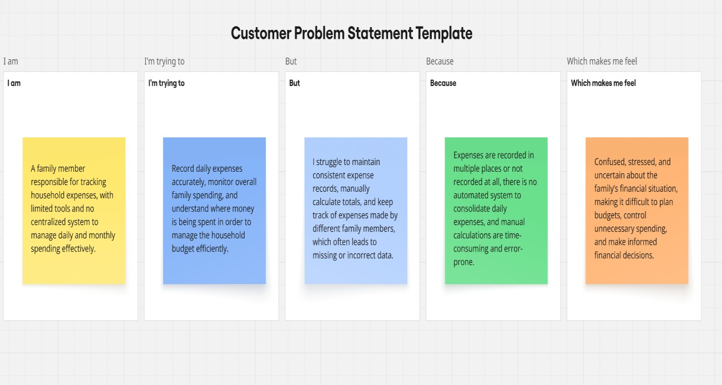

Problem  Statement (PS) | I am  (Customer) | I’m trying to | But | Because | Which makes me  feel
PS-1 | Family Head  / Expense  Manager | Track and consolidate daily expenses  of all family  members  accurately | I don’t have a centralized system to capture and calculate expenses automatically | Expenses are recorded manually or inconsistently, and there is no automation to aggregate daily spending into a single view | Stressed about losing control over finances and unsure about the actual monthly expenditure
PS-2 | Individual  Family  Member | Record daily expenses quickly and ensure they are counted in the overall family budget | I find it difficult to ensure my expenses are properly recorded and reflected in the total | There is no structured platform to log expenses daily and link them to family-level records | Frustrated and disconnected from the family’s financial planning process

